
A 10
SET NO : 1

Sreenidhi Institute of Science & Technology
(An Autonomous Institution)
Code No: 101ME02

B. TECH. I – Year II – Semester Examinations, July/Aug, 2011 (Regular - FN)
ENGINEERING DRAWING - II (CSE)

Time: 3 Hours Max. Marks : 70

Note : No additional answer sheets will be provided.

Part-A (Objective Type)
Max.Marks:20

Answer all QUESTIONS.

- Differentiate between intersection of surfaces and interpenetration of solids.
- List out the applications of intersection of surfaces.
- Define the term, "Line of intersection".
- Draw an isometric projection of a square plane of side 40.
- Draw the isometric view of a circle of 50 diameter.
- Define station point.
- Differentiate isometric projection and isometric view.
- Computer aided graphics system have 3 major components. What are they?
- What are the Basic commands of AutoCAD?
- List the various options available to draw an Arc in AutoCAD?

Part – B
Max. Marks: 50
ANSWER ANY FIVE QUESTIONS.
EACH QUESTION CARRIES 10 MARKS.

- A vertical square prism, base 50 mm side is completely penetrated by a horizontal square prism, base 35 mm side so that their axes are 6 mm part. The axis of the horizontal prism is parallel to the V.P., while the faces of both prisms are equally inclined to the V.P. Draw the projections of the prisms showing line of intersection.

- A vertical cylinder of 80mm diameter, is penetrated by another cylinder of 50mm diameter. The axis of the penetrating cylinder is parallel to both H.P and V.P and is 10mm away from that of the vertical cylinder. Draw the projections showing the lines (curves) of intersection.

- Draw the isometric view of a cone of base diameter 30mm and axis 45mm long, in the following positions:
  - Base lying on H.P.
  - Base lying on V.P.

- A hexagonal prism with side of base 25 and axis 50 long, rests centrally on one of its rectangular faces, on a cylindrical block of 75 diameter and 25 thick. The cylindrical block rests on its base on H.P. and the axis of the prism is perpendicular to V.P. Draw the isometric view of the combination of the two solids.

- The FV and TV of an object are shown below. Draw its isometric projection.

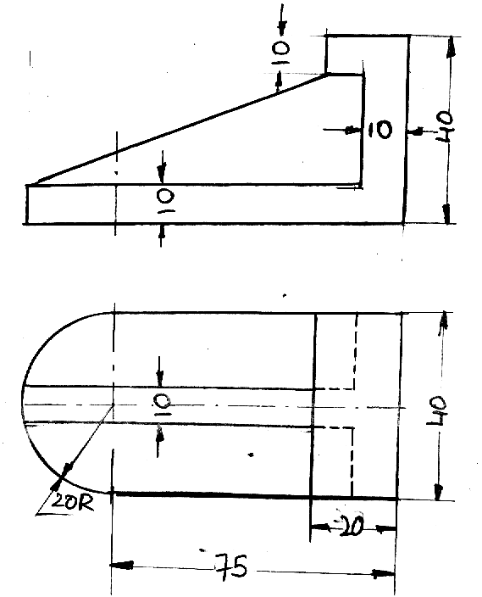

- Draw FV, TV and right side view of the object shown below.

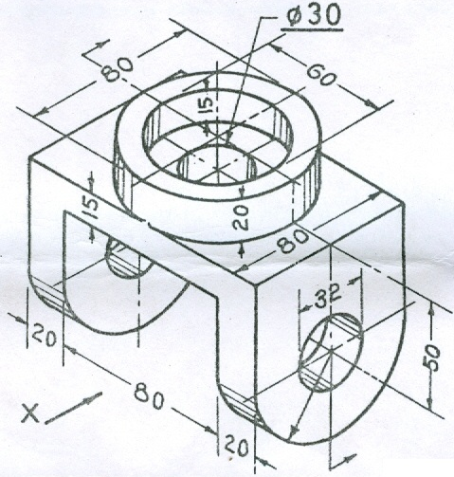

- A hexagonal plane of side 30, is resting on an edge on the ground with its surface inclined at 30⁰ to P.P. The nearest corner of the plane is 10 away from P.P. The station point is 50 in front of P.P. and 80 above G.L and in the central plane of the object. Draw its perspective view.

- Explain the procedure for creation of 3D primitives (objects) in computer aided drafting (AutoCAD).
-- 00 -- 00 --

